

Online Post Office Management System

Online Post Office Management System

# PROJECT GROUP MEMBERS

|  |  |
| --- | --- |
| **Students Id** | **Student Name** |
| **Student1206789** | **Masooma** |
| **Student1204065** | **Dania Shabih** |
| **Student1205772** | **Taha Naeem** |

**CURRICULUM BATCH**

**6740 1908F1**

# FACULTY

**MS. SAMREEN RAFIQ**

# CO-ORDINATOR

**MS. RIMSHA**

Online Post Office Management System

**SCREEN SHOTS**

Online Post Office Management System

# Create Account

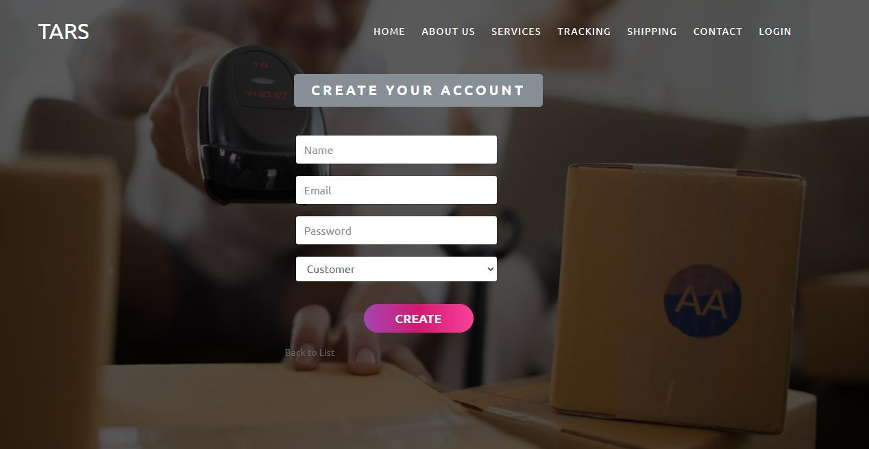User can create an account whether they will be customer, employee or head.

# Read Details

Employee and head can read the details of registered users.

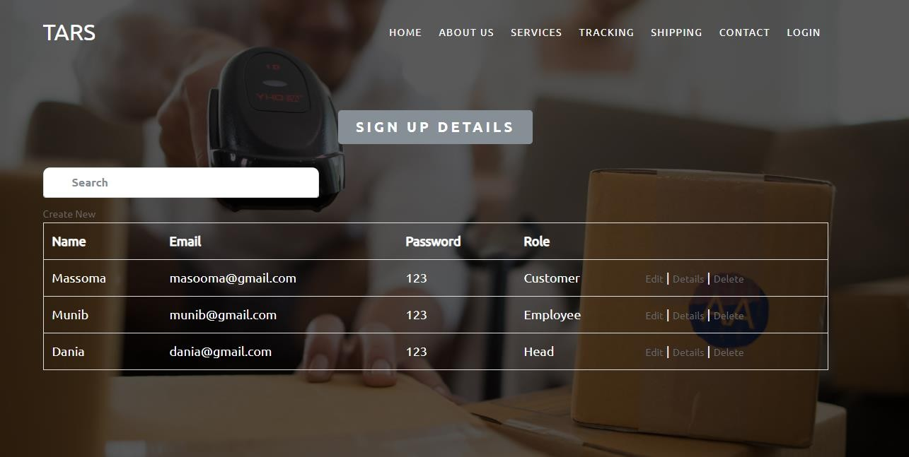

Online Post Office Management System

# Update Details

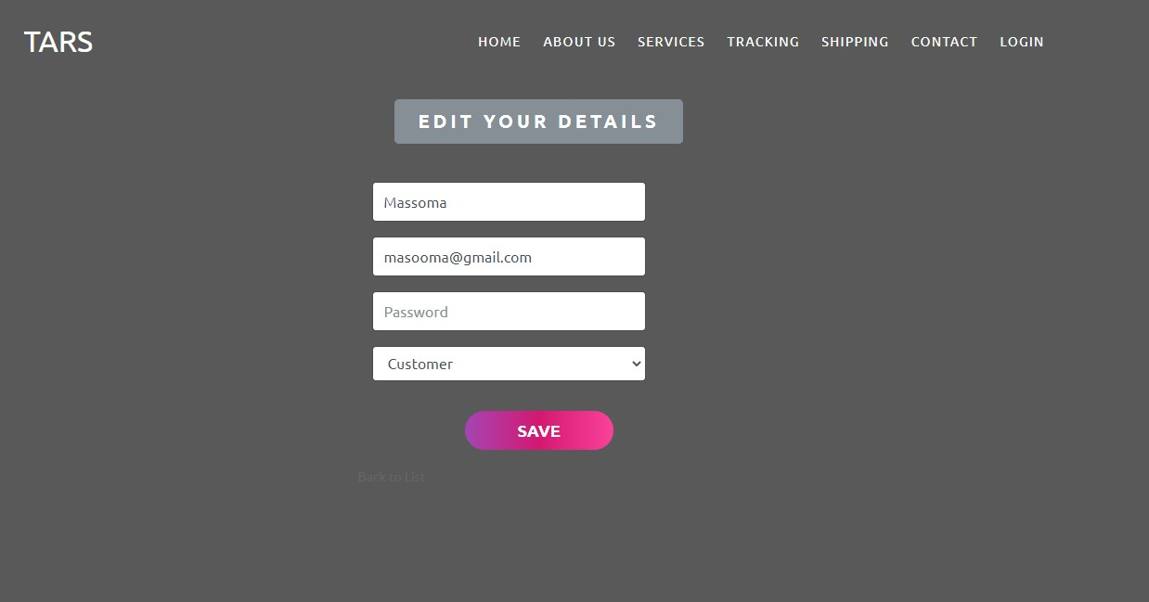User can correct their information if they entered wrong information.

# Delete Details

Employee and head can delete inappropriate details

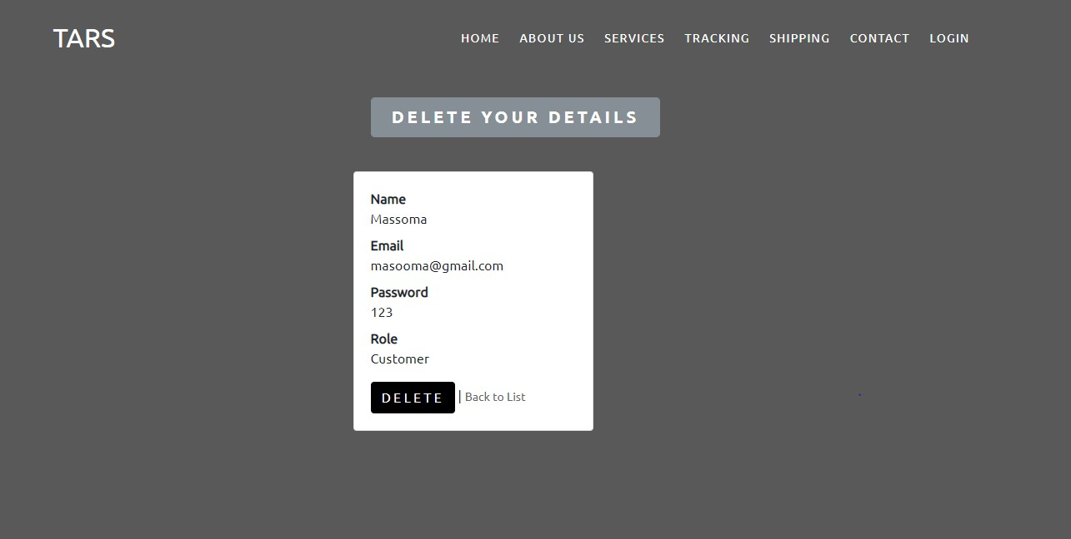

Online Post Office Management System

# Home Page Header

When user open our website, they will see this user- friendly home page.

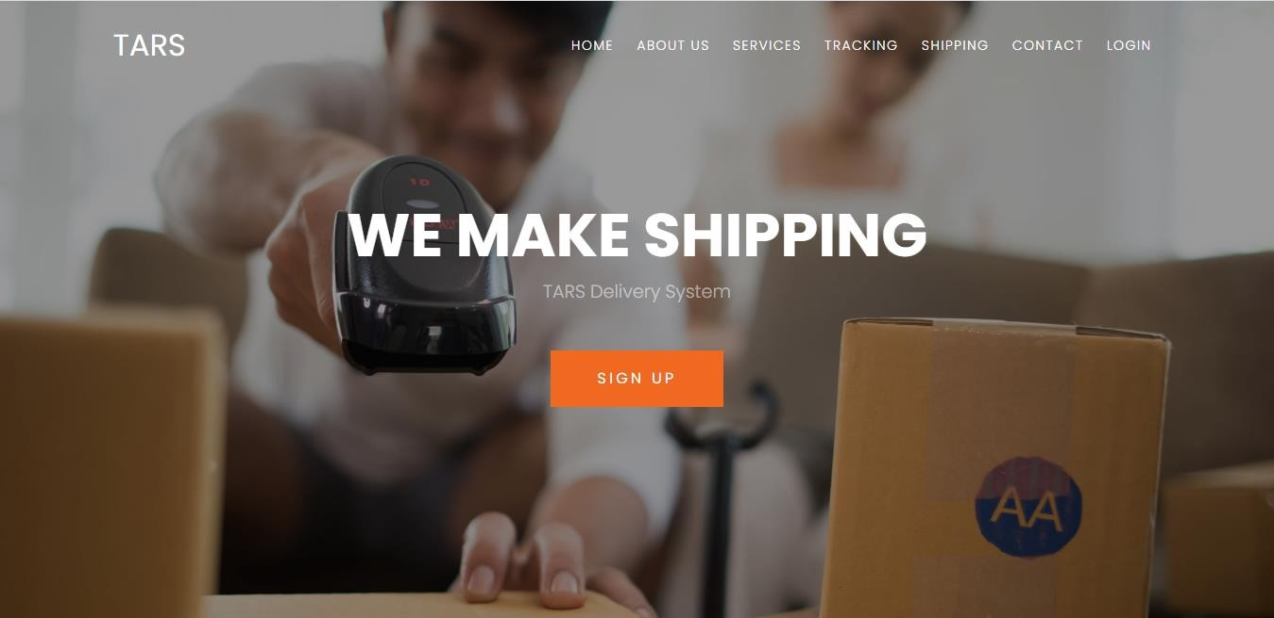

# Footer

In the end of the website user can see this footer which have some links.

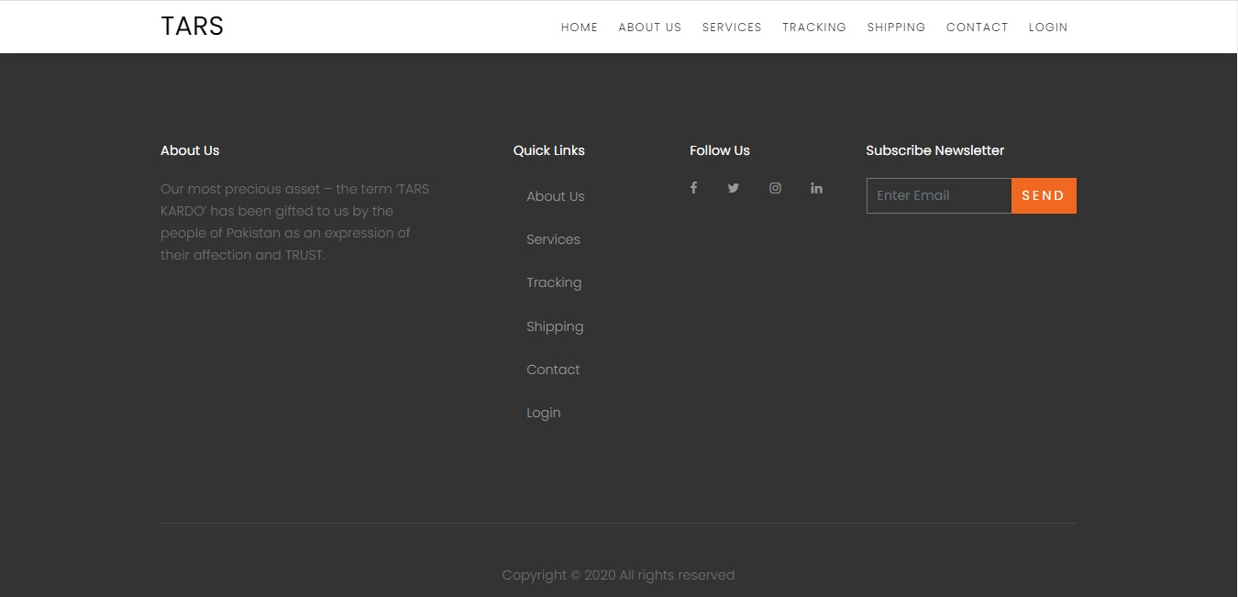

Online Post Office Management System

# Weight Converter

User can convert weight before placing order.

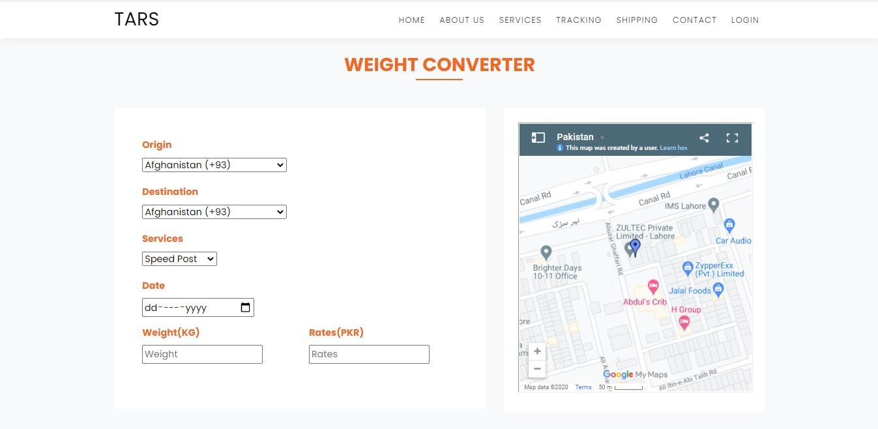

# Industries

Our home page can show user’s about or industries.

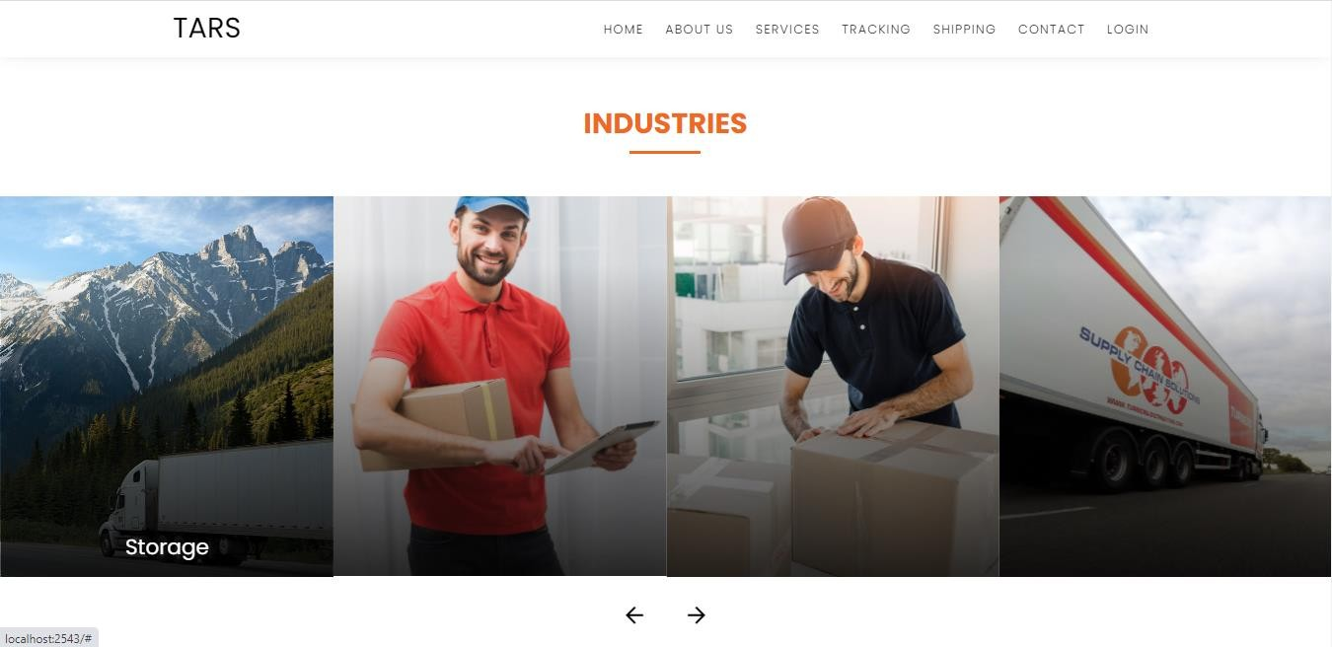

Online Post Office Management System

# About Us

About us shows some details of organization.



# Our Services

User can easily find our services.

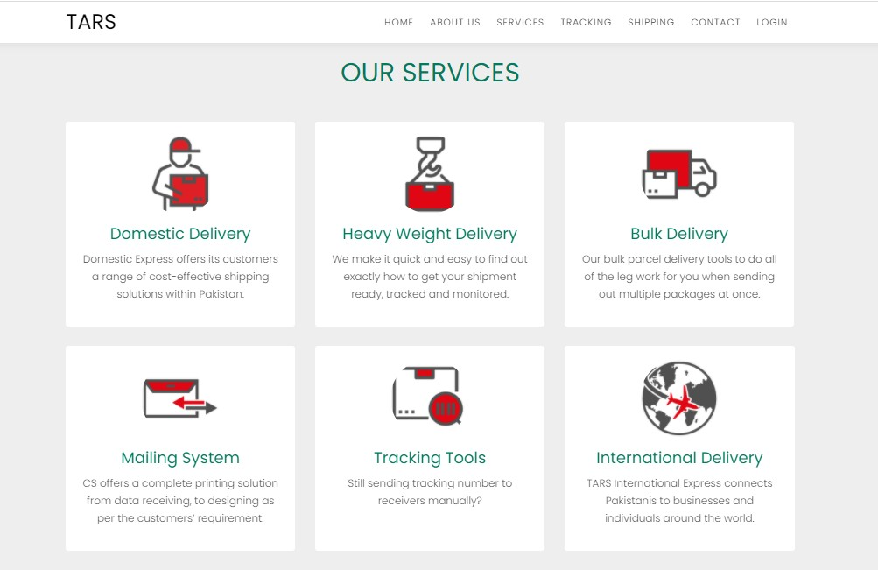

Online Post Office Management System

# Track Your Order

When user place an order then they will track their order easily.

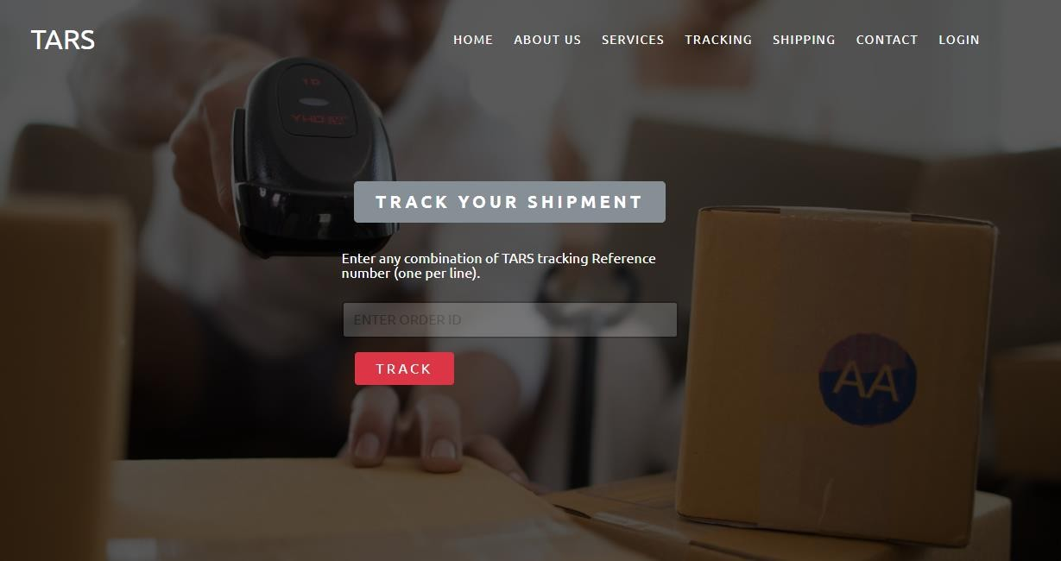

# Create A Shipment

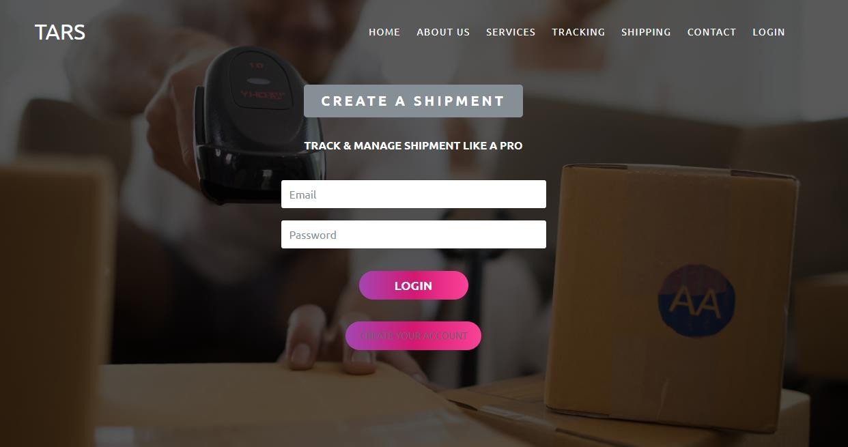User can create a shipment by register themselves and placing order.

Online Post Office Management System

# Contact Us

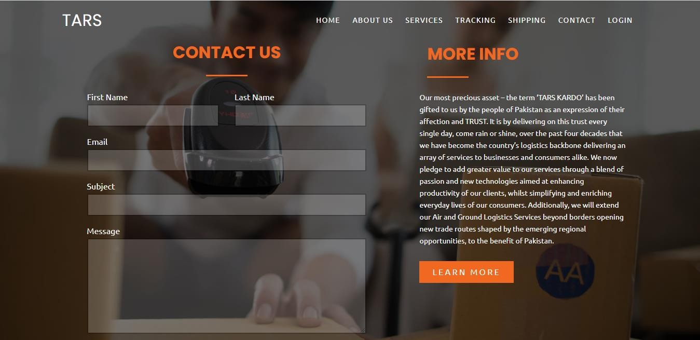User can contact if they had any issue in placing order.

# Login

User can Login and register themselves.

